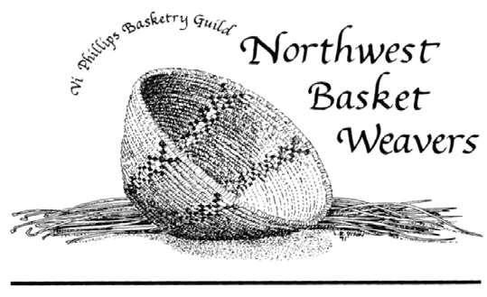
Mary Irvine Basket Day
August 17, 2019
Saturday 9:00am - 5:00pm
The Granite Curling Club
1440 North 128th Street, Seattle WA 98133
Registration opens June 15th
Join us for Basket Day! The Mary Irvine Basket Day is a Northwest Basket Weavers Guild sponsored event providing workshops to Guild members and the public. The Guild pays the instructors and students pay only the materials fee and a small registration fee to cover the cost of venue rental. Registration opens between June 15th and July 25th, but don’t dally, classes will fill up fast!
Classes are filled on a first come, first served basis. Please indicate your first, second, and third choice. Include the $10 registration fee and the materials fee of your first choice, as a deposit. Any balance will be paid by each student directly to the instructor on class day.
Cancellation Policy: Your deposit will be refunded if you cancel prior to July 15th. After July 15th, there will be a refund only if your place can be filled from the waiting list or if you find a replacement student for the class.
You don’t have to register to spend the day weaving with us! In addition to classes, there will be space for open weaving, visiting, and sharing techniques. If you are stuck on a project, bring it along for help. There are usually experienced weavers available to help you. You can also just come for the potluck lunch or drop by anytime to check out what’s happening and visit with other Guild members.
There will be an hour lunch break from 1:00 to 2:00 depending on the class. Please bring a potluck dish to share for lunch, your preferred beverage, and snacks to share if you wish. Coffee, tea, and bottled water will be provided.
The Guild will have merchandise, including tools and waxed linen, for sale - please bring cash or check book!
See class listings and registration form below.
Registration questions email: mytbasket@comcast.net
General inquiries email: BasketDay@nwbasketweavers.org
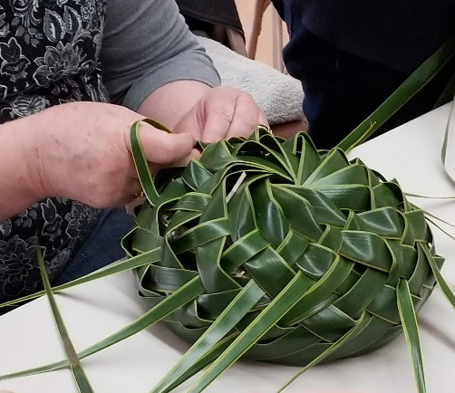
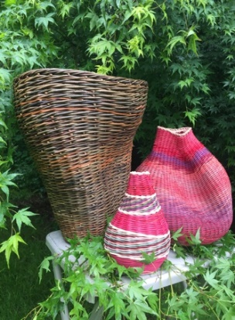
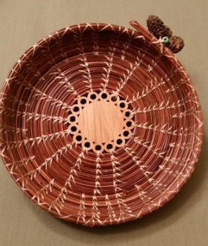
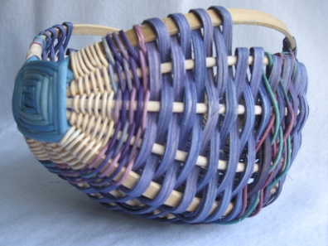
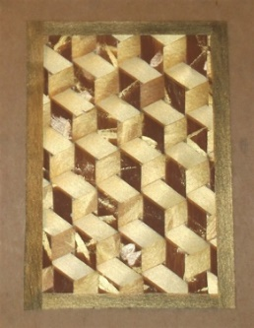
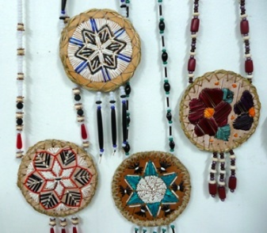
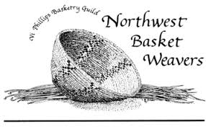
Mary Irvine Basket Day
Class Full
Class Full
Cancelled
Mamfok Means to Weave
Class F: MAMFOK Means To Weave
Instructor: Roquin-Jon Siongc
Skill Level: All Levels Materials Fee: $30.00
3.5 hours (please indicate morning or afternoon)
Class Description: Chamoru weaver Roquin-Jon Siongco will guide you to weave with fresh palm leaves (Cocos nucifera), using techniques found throughout the Pacific, where weaving is an integral part of life. You will explore a few approaches using this material, and leave with a fresh woven basket! All necessary tools supplied by teacher.

Class E: Wicker Weaves
Instructor: Kay Harradine
Skill Level: All Levels Materials Fee: $25
Class Description: Focus on shaping and control, using “power weaves.” All levels are welcome– beginners will learn wicker basics by making a fruit bowl; more experienced weavers will exercise their creativity through choices in color, pattern and shape. Students will make a shapely basket with dyed and natural round reed, approximately 8” wide by 10” tall.
Bring a photo or sample of your wicker work if you have one.
Tools to Bring: Small bucket, towel, sharp basket scissors, awl, pocketknife, pencil, Band-Aid.
If you have a copy of a Flo Hoppe book, bring that too!
Wicker Weaves
Class D: Beginning Pine Needle Basket
Instructor: Vicky Nickelson
Skill Level: Beginner Materials Fee: $20
Class Description: This is a beginning pine needle coiled basket using the versatile Wheat and Fern Stitch. Students will learn how to start a pine needle coil around a prepared laser-cut cedar disc using faux sinew for stitching.
Tools to Bring: Scissors and a thimble.
A task light is also recommended– cordless please!
Beginning Pine Needle Basket
Class C: Contemporary Hoop and Ribs Basket
Instructor: Elaine Twogood
Skill Level: All Levels Materials Fee: $25
Class Description: Learn how to use a brace to help with shape and support as you weave. Students will create the frame for their basket using two 8” hoops held together with a “God’s Eye,” add round-reed ribs and weave using reed and other fibers.
Tools to Bring: Scissors, needle nose pliers, tape measure, awl, packing tool, clips, knife, pencil, spray bottle, towel, basin for soaking materials. Some basic tools will be available.
Contemporary Hoop and Ribs Basket
Class B: Mad Weave Tumbling Blocks
Instructor: Sheila Wray
Skill Level: Beginner Materials Fee: $25
Class Description: Create a work of art while learning to mad weave! Students will make an 8”x10” matted, flat, tumbling-block, paper design. A second project may be started or paper may be painted for future projects as time permits. Color choices: brown/bronze/gold or teal/blue/while. No special skill is required but a calm, patient mood is helpful.
Tools to Bring: Craft scissors (for paper cutting), small clips, old hand towel.
Mad Weave Tumbling Blocks
Class A: Porcupine Quill on Birch Bark Medallion
Instructor: Kathy Ervine
Skill Level: All Levels Materials Fee: $55
Class Description: Porcupine quills– both natural white and dyed– are ‘stitched’ onto prepared birch bark discs. There will be a variety of patterns available to transfer onto the medallions, or you may bring your own.
Tools to Bring: Scissors, small hemostats (instructor will provide if needed).
Porcupine Quill on Birch Bark Medallion
Mary Irvine Basket Day
2019 Classes
there is a $10 registration fee for all classes
August 17, 2019
Registration Form
Student Name: ___________________________
Email: ______________________________ _____ Phone: _____________
Mailing Address: _____________________________________________________
1st Choice: Class # _______ materials fee enclosed: $_______
2nd Choice: Class # _______
3rd Choice: Class # _______
____ I am NWBW member ____ I am a NWBW guest ____ I would like to join the Guild
I can help with:
____ Whatever is needed
____ AM Set-up ____ Check In
____ Lunch Set-up ____ Lunch Clean-up
_____End of Day Clean-up
Include payment for your 1st choice materials fee and $10 registration fee. Checks should be made payable to Northwest Basket Weavers. Mail to:
Mary Irvine Basket Day
c/o Myra Tanita, 4407 1st Ave NW
Seattle WA, 98107
Final registration deadline: Postmarked by July 25th.
Class confirmations and information about tools and other things to bring will be sent by email the first week of August. If you wish to have your class confirmation mailed, please include a SASE.
Registration questions email Myra at: mytbasket@comcast.net
General inquiries contact: BasketDay@nwbasketweavers.org

